**Single Page – CRUD Application for Student Admission Entry**

The Application allows you to enter the students name,

The dashboard as follows

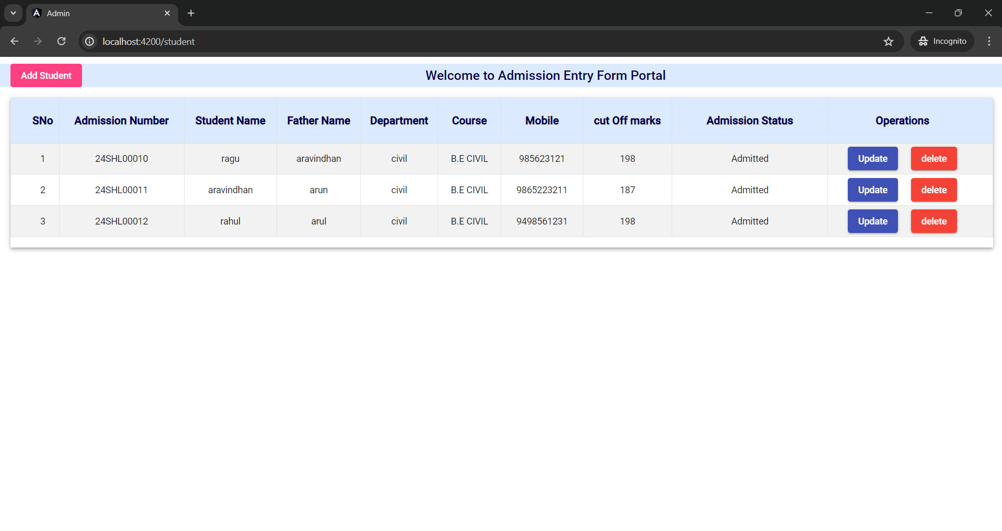

On clicking the add Student Button the Pop Up opens and Gives Information

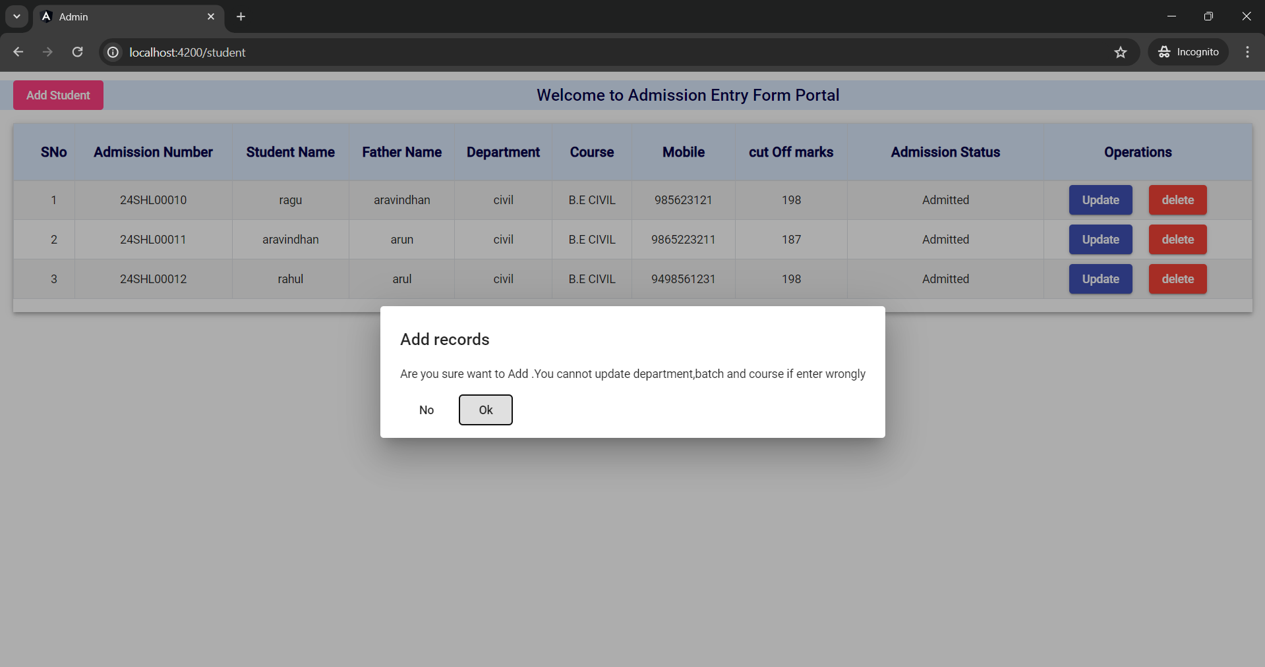

On clicking ok button it shows the add student dialog , if clicks on no it return to dashboard

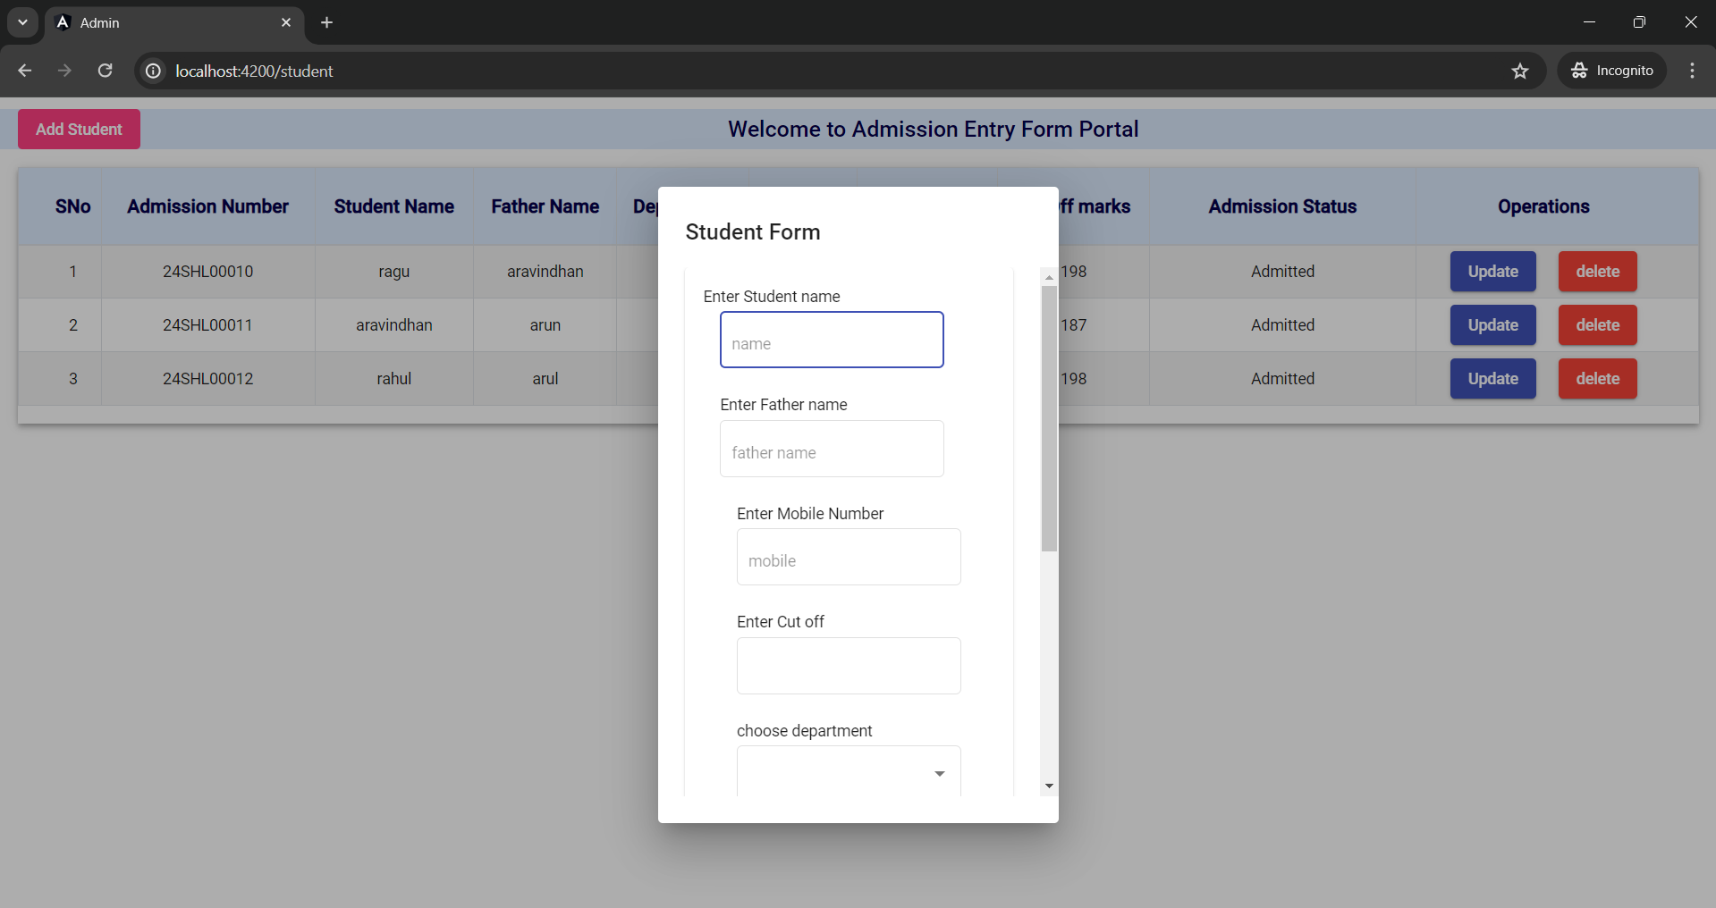

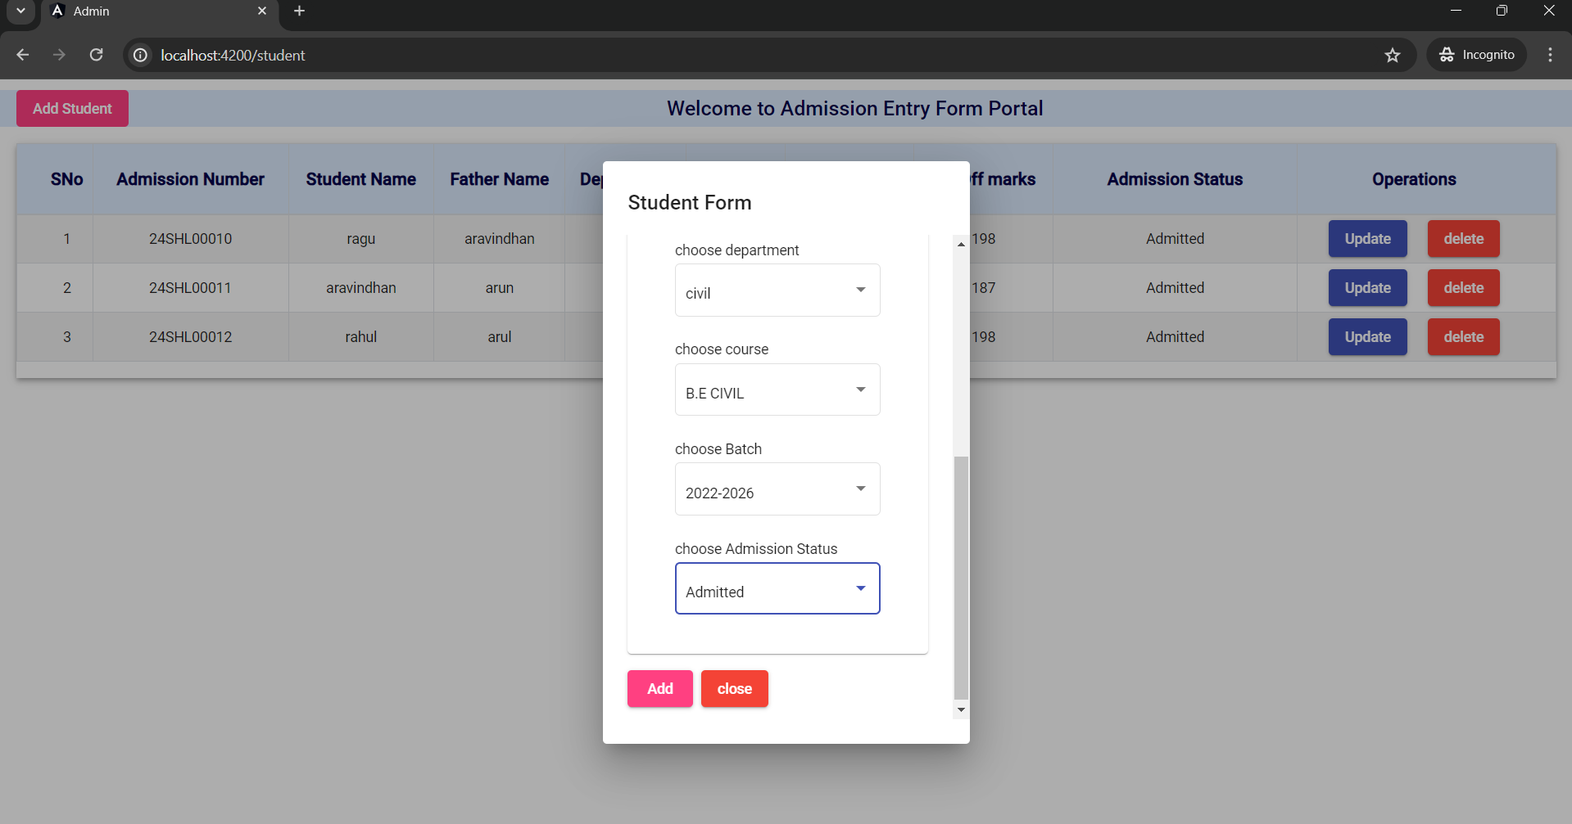

The Record is added .It shows as follows in the dashboard

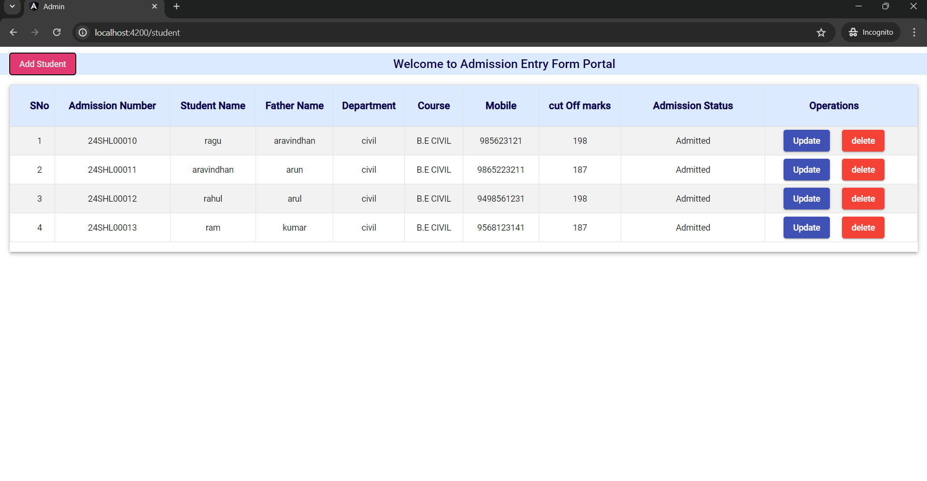

You can Update any record by clicking on the update button on clicking it, it shows a pop message as follows

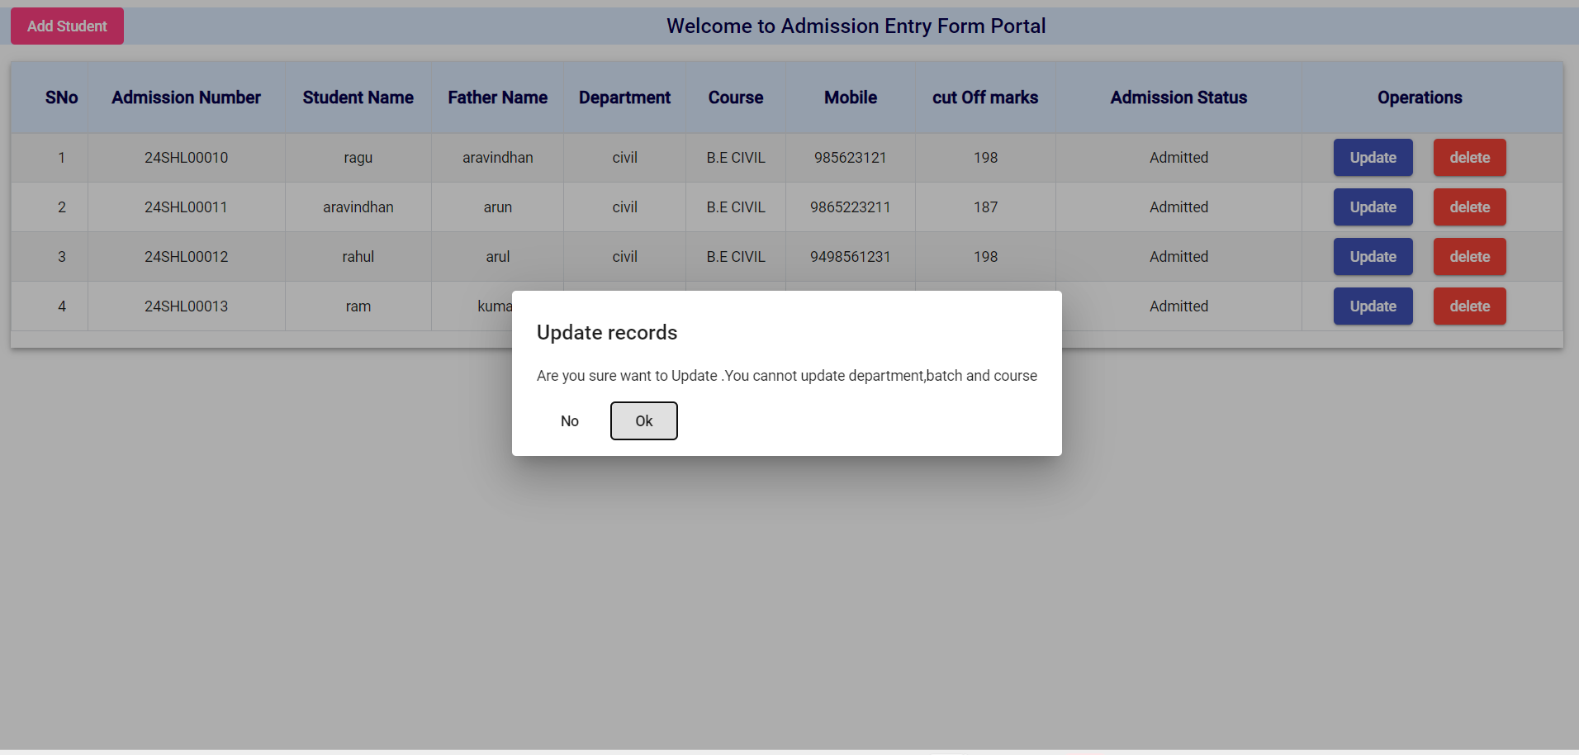

If clicks on ok Update record wizard opens

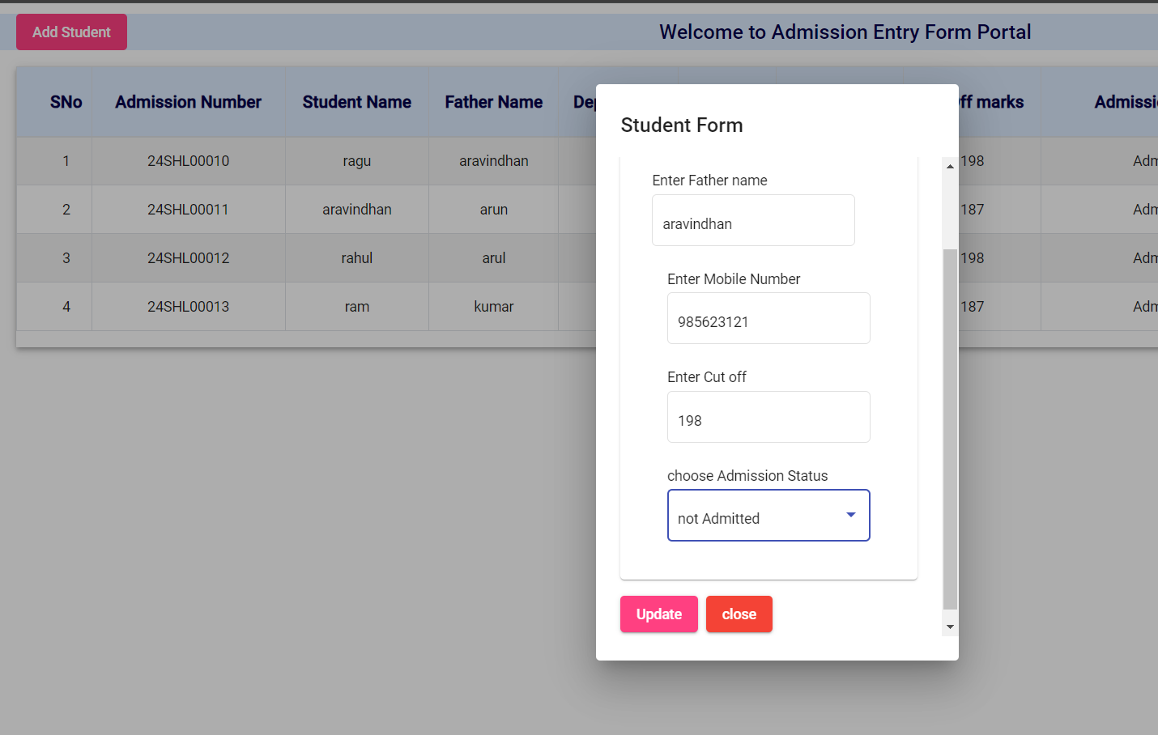

You can update the record by clicking on the update button .It reflects in the dashboard automatically



You can Delete any record by clicking on the delete button on clicking it, it shows a pop message as follows

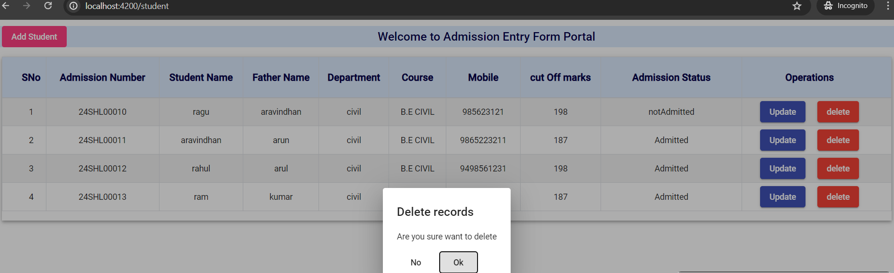

You can delete the record by clicking on the ok button.It reflects in the dashboard automatically

